CISCO
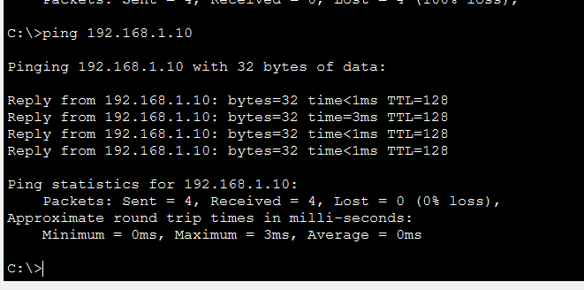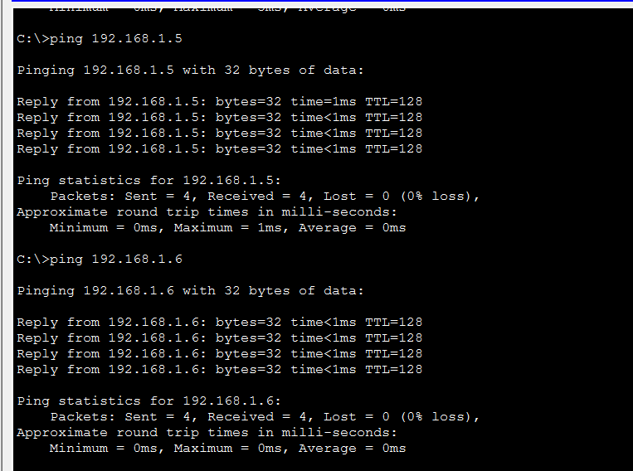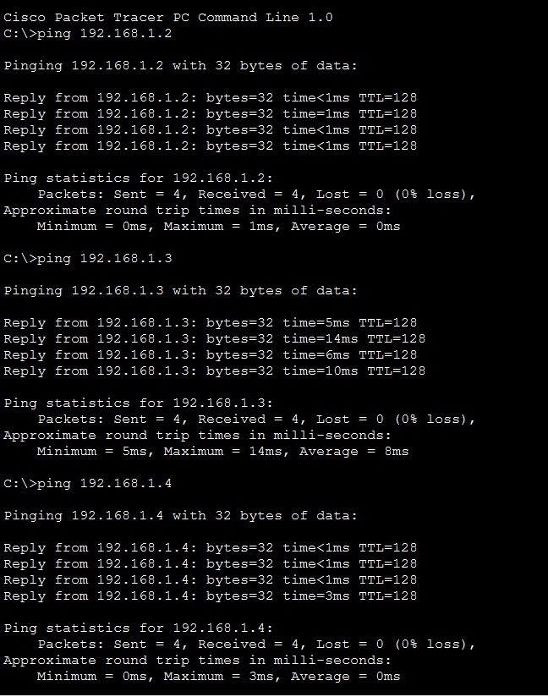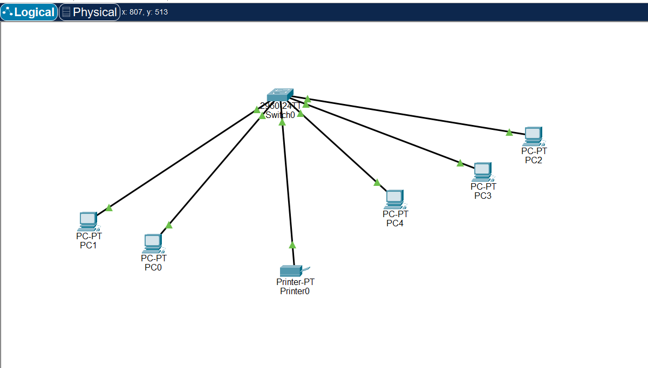

-Connect all PCs and Printer to Switch and Assigned Respective IP addresses given in the question
-Connecting with copper straight through and used Fast Ethernet connections to form topology.
-Checking them through command line using ping {IP address} to see whether they are all connected
-Virtual Printer and Printer sharing cannot be found in latest version(s).

